Table of Contents

**Microsoft Fabric: A Comprehensive Solution for Data and Analytics** 1

Introduction 1

Components of Microsoft Fabric: 2

1. Data Factory 2

2. Synapse Data Engineering 2

3. Synapse Data Science 3

4. Synapse Data Warehouse 3

5. Synapse Real-Time Analytics 3

6. Power BI (Embedded in Fabric) 3

7. OneLake 4

TABULAR FORM of Components Role and Responsibilities: 6

Architecture 7

Medallion architecture in Fabric 7

Migration Strategies 8

Cost Effectiveness 8

Security Considerations 8

Benefits of Microsoft Fabric: 9

Current Setup Vs Microsoft Fabric: 10

Conclusion: 11

# **Microsoft Fabric: A Comprehensive Solution for Data and Analytics**

Introduction**:**

**Microsoft Fabric**, which is a comprehensive, unified platform introduced by Microsoft in 2023. It integrates data engineering, data science, and data analytics into a single environment. Fabric combines various tools, including **Power BI, Azure Synapse Analytics, and Azure Data Factory**, to enable seamless data management, real-time analytics, and AI-powered insights, all within a single SaaS platform.

Components of Microsoft Fabric:

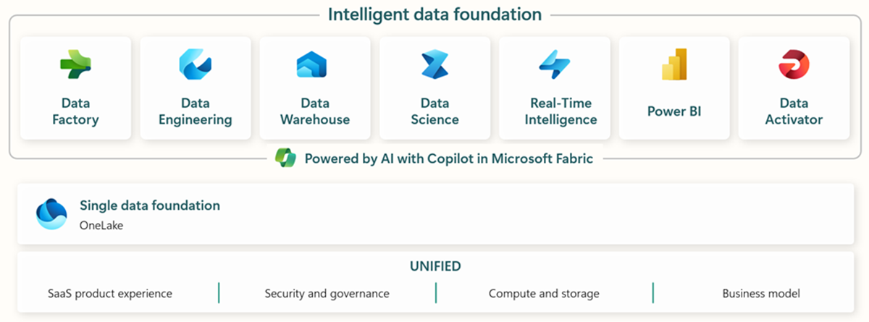

### 1. Data Factory

* **Purpose**: Handles **data ingestion** and **integration**.
* **Functionality**: Similar to **Azure Data Factory (ADF)**, it allows you to create **ETL (Extract, Transform, Load)** pipelines.
* **Features**:
  + **Dataflows**: UI-based data transformation.
  + **Data Movement**: Connects to various data sources, both cloud-based and on-premises.
* **Use Case**: Automate the collection of data from multiple sources like databases, APIs, or file systems and load it into **OneLake**.

### 2. Synapse Data Engineering

* **Purpose**: Focuses on **data transformation** and **processing**.
* **Functionality**: Supports **Apache Spark** and **notebooks** (using **Python, Scala, SparkSQL,** and **R**).
* **Features**:
  + **Data Cleaning and Transformation**: Use **Spark** for big data processing.
  + **Notebooks**: Build reusable scripts and pipelines for data transformation.
* **Use Case**: Clean raw data, aggregate it, and prepare it for further analysis or storage in a **data warehouse**.

### 3. Synapse Data Science

* **Purpose**: Provides tools for **machine learning** and **AI** model development.
* **Functionality**: Integrates with **Azure Machine Learning** for model training, deployment, and experimentation.
* **Features**:
  + **Notebooks for Data Science**: Build models using **Python** and **R**.
  + **Integration with Machine Learning Models**: Use pre-built models or deploy custom models.
* **Use Case**: Build predictive models for customer behavior analysis directly within the Fabric environment.

### 4. Synapse Data Warehouse

* **Purpose**: Acts as a **data warehouse** for storing processed and **structured data**.
* **Functionality**: Optimized for **T-SQL** queries and analytical workloads.
* **Features**:
  + **Structured Data Storage**: Store and manage **cleaned and aggregated data**.
  + **High-Performance Querying**: Run complex SQL queries for analysis.
* **Use Case**: Store aggregated sales data and perform complex queries to generate reports.

### 5. Synapse Real-Time Analytics

* **Purpose**: Focused on **real-time data analytics** and **streaming data processing**.
* **Functionality**: Uses **Kusto Query Language (KQL)** for querying **real-time event streams**.
* **Features**:
  + **Event Stream Processing**: Analyze live data streams from sensors, IoT devices, or logs.
  + **Real-Time Dashboards**: Generate dashboards that reflect up-to-the-minute data.
* **Use Case**: Monitor real-time sales data during a promotional campaign to adjust strategies on the fly.

### 6. Power BI (Embedded in Fabric)

* **Purpose**: Provides **data visualization** and **business intelligence** capabilities.
* **Functionality**: Allows users to create **dashboards, reports, and interactive visualizations**.
* **Features**:
  + **Integration with OneLake and Synapse**: Directly access data stored in **OneLake** or processed through **Synapse**.
  + **AI-Assisted Reporting**: Use **Co-pilot** features to generate insights.
* **Use Case**: Create dashboards to visualize sales performance, inventory status, and customer feedback.

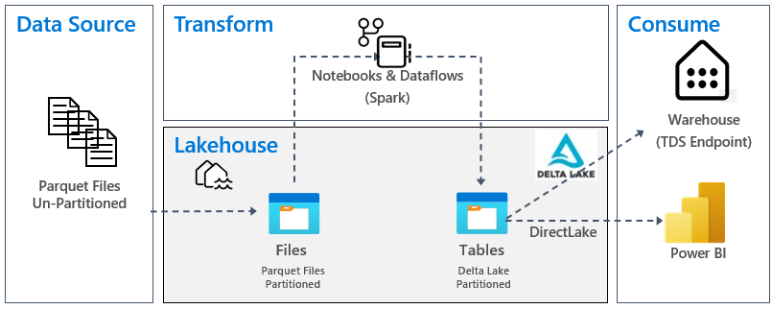

### 7. OneLake

* **Purpose**: Acts as the **central data lake** for storing all types of data (structured, semi-structured, unstructured).
* **Functionality**: Built on **Azure Data Lake Storage Gen2 (ADLS Gen2)** but tailored for **Microsoft Fabric**.
* **Features**:
  + **Lakehouse Architecture**: Stores both raw data (like data lakes) and structured, queryable data (like data warehouses).
  + **Parquet and Delta Format Support**: Compatible with modern analytics frameworks.
* **Use Case**: Store raw transactional data from multiple sources and prepare it for transformation and analysis.

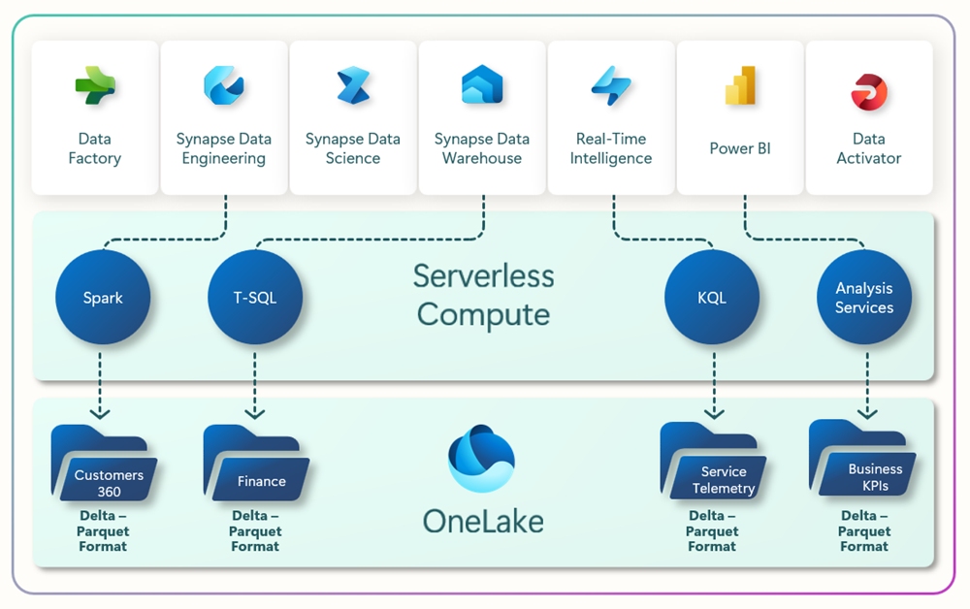

OneLake is open at every level. OneLake is built on top of Azure Data Lake Storage (ADLS) Gen2 and can support any type of file, structured or unstructured. All Fabric data items like data warehouses and lakehouses store their data automatically in OneLake in Delta Parquet format. If a data engineer loads data into a lakehouse using Apache Spark, and then a SQL developer uses T-SQL to load data in a fully transactional data warehouse, both are contributing to the same data lake. OneLake stores all tabular data in Delta Parquet format.

OneLake supports the same ADLS Gen2 APIs and SDKs to be compatible with existing ADLS Gen2 applications, including Azure Databricks. You can address data in OneLake as if it's one big ADLS storage account for the entire organization. Every workspace appears as a container within that storage account, and different data items appear as folders within those containers.

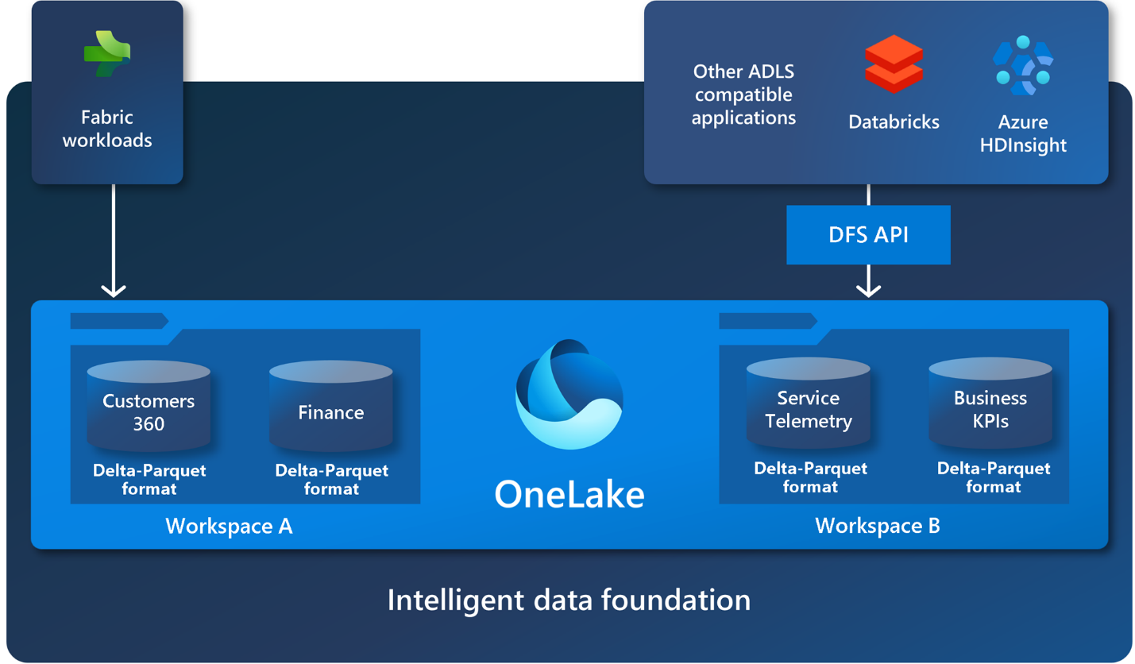

TABULAR FORM of Components Role and Responsibilities:

| **Component** | **Role** | **Key Functionality** |
| --- | --- | --- |
| **Data Factory** | Data ingestion and integration | ETL pipelines, data movement |
| **Synapse Data Engineering** | Data processing and transformation | Spark-based data cleaning, transformation, and aggregation |
| **Synapse Data Science** | AI and machine learning | Notebooks for model building and deployment |
| **Synapse Data Warehouse** | Structured data storage and analysis | T-SQL queries, high-performance analytics |
| **Synapse Real-Time Analytics** | Real-time data processing | KQL for streaming data and live event analysis |
| **Power BI** | Data visualization and reporting | Dashboards, interactive reports |
| **OneLake** | Centralized storage for raw and processed data | Unified storage with lakehouse architecture |

Architecture**:**

Medallion architecture in Fabric:

In a typical medallion architecture implementation in Fabric, the bronze zone stores the data in the same format as the data source. When the data source is a relational database, Delta tables are a good choice. The silver and gold zones contain Delta tables.

The goal of medallion architecture is to incrementally and progressively improve the structure and quality of data as it progresses through each stage.

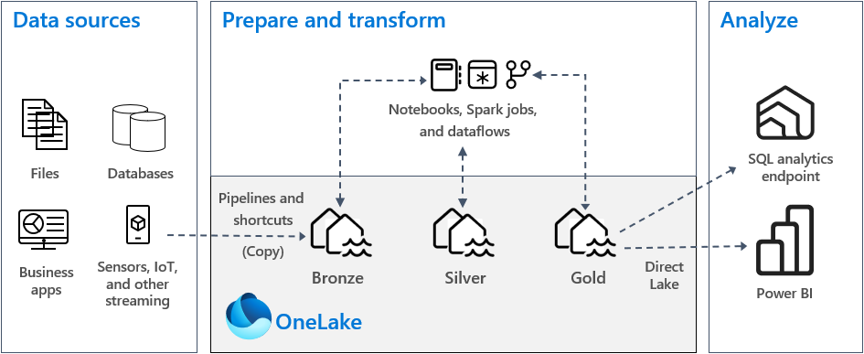

Migration Strategies:

Migrating to Microsoft Fabric from existing Azure services can be managed effectively through a phased approach, ensuring minimal disruption to our ongoing operations. Incremental data migration allows us to move less critical datasets first, test the new environment, and address any challenges before transitioning core data processes. This method can include parallel operation of both the old and new systems, ensuring data integrity and functionality. Reconfiguring data pipelines from Azure Data Factory to Fabric’s integrated Data Factory can be streamlined using pre-built connectors and automated scripts, simplifying the transition. Additionally, a pilot program helps identify potential issues early, allowing for adjustments before a full-scale rollout. This approach reduces risk and ensures a smooth and controlled migration to Microsoft Fabric.

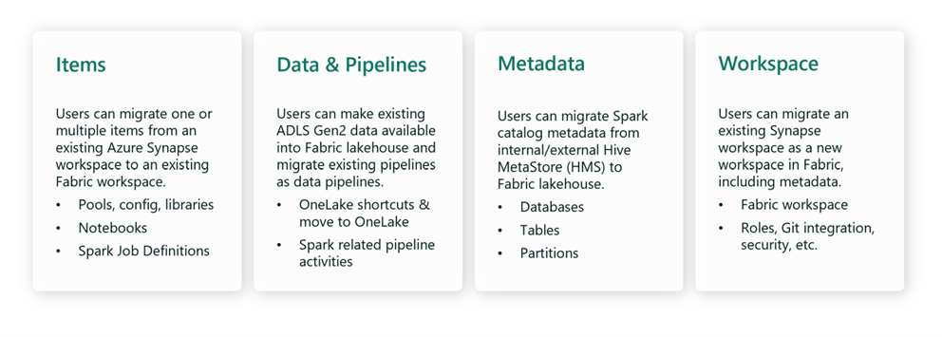

Cost Effectiveness:

Microsoft Fabric offers significant cost-saving opportunities through its unified platform approach, consolidating data ingestion, transformation, storage, and analytics under one roof. This integration can reduce the overhead associated with managing multiple separate services like Databricks, ADLS, and Azure Synapse Analytics. Fabric’s serverless, pay-as-you-go model enables organizations to pay only for the compute resources they use, avoiding unnecessary expenses during periods of low activity. By scaling resources dynamically, Fabric provides a cost-effective solution for businesses with fluctuating workloads. While there may be initial investments in setup and training, these are offset by long-term savings from reduced licensing fees, simplified management, and lower maintenance costs, making Fabric a financially viable choice for modern data needs.

Security Considerations:

Microsoft Fabric provides robust security features that ensure data protection and compliance throughout the data lifecycle. Integration with Azure Active Directory (AAD) offers secure user authentication and role-based access control (RBAC), allowing organizations to manage access to sensitive data effectively. Data stored in OneLake and Synapse is encrypted both at rest and in transit, safeguarding it against unauthorized access. Fabric’s built-in tools support compliance with industry standards such as GDPR and HIPAA, enabling businesses to maintain regulatory adherence with ease. Additionally, the use of Azure Security Center for continuous monitoring and threat detection, combined with real-time analytics from Synapse, ensures proactive identification and response to security incidents. This comprehensive security framework makes Microsoft Fabric a secure platform for data management and analytics.

The architectural diagram depicts the following concepts.

1. A user uses a browser or a client application, like Power BI Desktop, to connect to the Fabric service.
2. Authentication is handled by Microsoft Entra ID, [previously known as Azure Active Directory](https://learn.microsoft.com/en-us/entra/fundamentals/new-name), which is the cloud-based identity and access management service that authenticates the user or [service principal](https://learn.microsoft.com/en-us/entra/identity-platform/app-objects-and-service-principals?tabs=browser#service-principal-object) and manages access to Fabric.
3. The web front end receives user requests and facilitates sign-in. It also routes requests and serves front-end content to the user.
4. The metadata platform stores tenant metadata, which can include customer data. Fabric services query this platform on demand in order to retrieve authorization information and to authorize and validate user requests. It's located in the tenant home region.
5. The back-end capacity platform is responsible for compute operations and for storing customer data, and it's located in the capacity region. It leverages Azure core services in that region as necessary for specific Fabric experiences.

Benefits of Microsoft Fabric:

* **Unified Platform**: Microsoft Fabric combines various data services into a single platform, simplifying data management and reducing integration costs. This unification enhances the overall efficiency of data workflows and reduces the complexity of managing multiple systems​​.
* **Scalability**: The platform supports large-scale data processing with independent scaling of compute and storage resources. This scalability ensures that Microsoft Fabric can handle growing data volumes and complex analytics tasks, providing organizations with the flexibility they need to scale their operations​​.
* **Real-Time Insights**: We can use Microsoft Fabric’s real-time analytics capabilities to query data across their lakehouse and warehouse from a single engine. This ability has enabled them to save time and eliminate data silos, allowing for more effective customer insights. By analyzing real-time data, they can respond quickly to customer needs and market trends, enhancing its competitive edge​​​​.
* **Cost-Efficiency**: Microsoft Fabric is a cost-effective solution as it reduces storage and implementation costs. The pricing is based on the total computing and storage utilized. This helps organizations hugely in cost saving and eliminates the need for having separate charges for different services.**Simplified Data Management**: OneLake centralizes data storage, reducing the need for multiple data lakes.
* **The Ability To Bring Together Data From Multiple Sources:** Microsoft Fabric can connect to a wide range of data sources, including on-premises, cloud-based, and streaming data sources. This makes it easy to bring together data from different parts of an organization and to build end-to-end analytics solutions.
* **Low-Code Platform:**MS Fabric empowers data engineers, data analysts, and everyone on the team with low-code platform capabilities so that they can focus on complex data challenges. With AI-powered real-time analytics and Copilot, it will become easier for users to generate reports, write code, and query the data.

## Current Setup Vs Microsoft Fabric:

| **Feature** | **Current Tools** | **Microsoft Fabric** |
| --- | --- | --- |
| Data Ingestion | Azure Data Factory (ADF) | Fabric Data Factory (integrated) |
| Data Storage | ADLS Gen2 | OneLake |
| Data Transformation | Databricks | Synapse Data Engineering |
| Data Analysis | Synapse Analytics | Synapse Data Warehouse, Real-Time Analytics |
| Machine Learning | Azure ML + Databricks | Synapse Data Science |
| Visualization | Power BI | Embedded Power BI |
| Integration Complexity | Multiple services | Unified within Microsoft Fabric |

## Conclusion:

Microsoft Fabric and the existing Azure tools each bring unique strengths to the table, making them suitable for different business needs. Microsoft Fabric stands out as a unified platform, offering an all-in-one solution for data integration, transformation, real-time analytics, and visualization. Its integrated components, such as Data Factory, Synapse Data Engineering, and OneLake, make it ideal for organizations looking to simplify their data management processes and gain real-time insights through a streamlined platform.

On the other hand, the current Azure services like Azure Synapse Analytics, ADLS, and Databricks are better suited for specific, tailored data workflows. These tools offer granular control over different aspects of data processing and are particularly advantageous when handling large-scale data warehousing or custom data processing scenarios.

The decision between adopting Microsoft Fabric or continuing with the current Azure services depends on the organization’s priorities. If the goal is to reduce complexity, centralize data management, and achieve end-to-end analytics within a single ecosystem, Microsoft Fabric is the preferred choice. However, if the focus is on customizing each aspect of data handling, leveraging advanced analytics capabilities, and working with specific data engineering tools, then the existing Azure services may remain the better option.